**WEEK-2**

**2.A) Identify the Components that are Power by the PSU.**

The PSU plays a crucial role in providing power to various components of the computer system, and here's an in-depth breakdown of those components:

1. **Motherboard:**

The motherboard is the main circuit board in the computer, and it's the central hub for connecting and coordinating all other hardware components. The PSU supplies power to the motherboard, which, in turn, distributes power to other components through its power connectors.

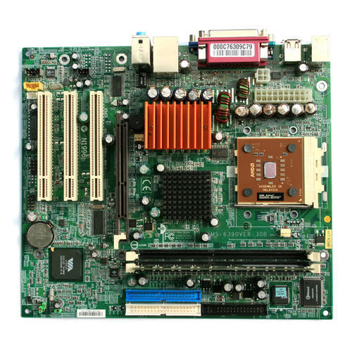

1. **Central Processing Unit (CPU):**

The CPU is often referred to as the brain of the computer. It requires a significant amount of power to perform complex calculations and execute instructions. The PSU provides the necessary voltage to the CPU through its dedicated power connectors.

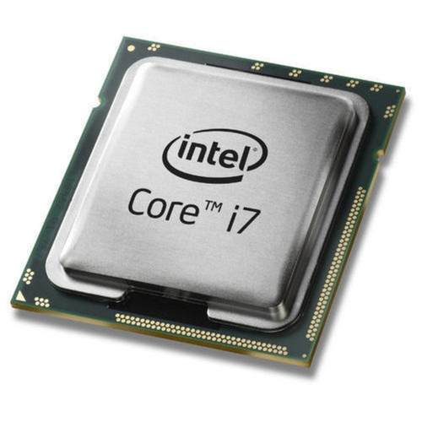

1. **Graphics Processing Unit (GPU):**

Both integrated graphics on the motherboard and discrete GPUs require power. Discrete GPUs have their power connectors, and the PSU supplies power to them. High-end GPUs can be particularly power-hungry.

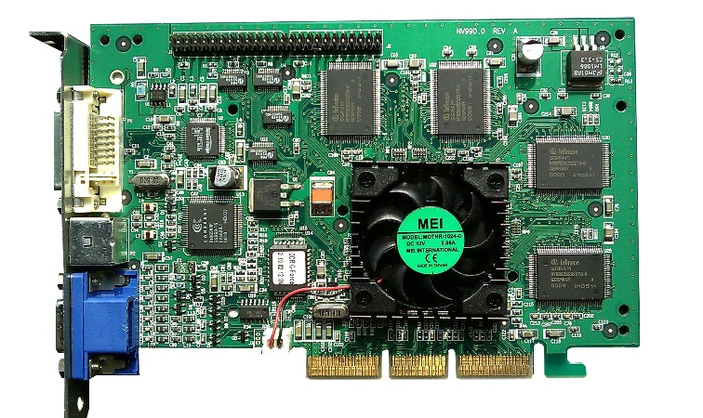

1. **RAM (Random Access Memory):**

While RAM doesn't have its own power connectors, it relies on the motherboard's power supply to operate. The PSU indirectly powers RAM modules through the motherboard.

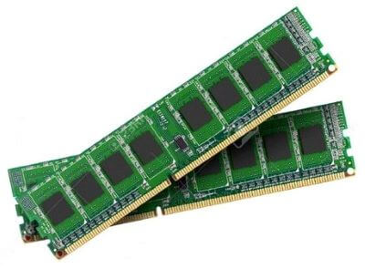

1. **Storage Drives:**

Hard Disk Drives (HDDs) and Solid-State Drives (SSDs) store and retrieve data in a computer. The PSU powers these drives through the SATA power connectors or other appropriate connectors.

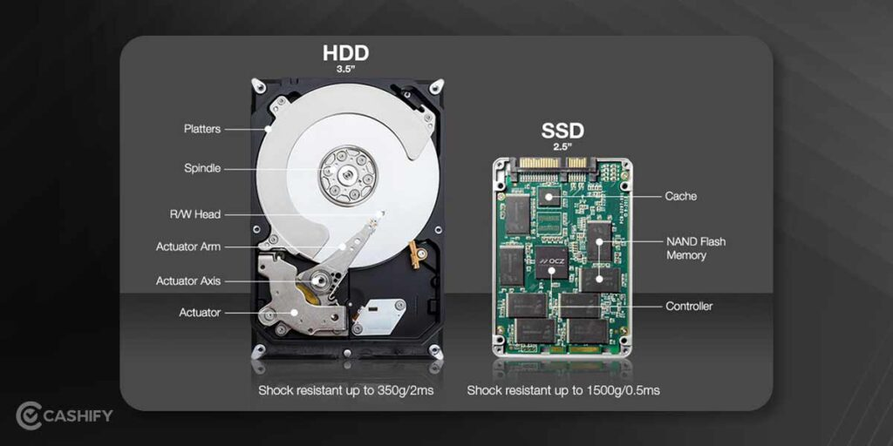

1. **Optical Drives:**

Optical drives, such as CD/DVD drives, are becoming less common, but they still need power to read and write optical discs. The PSU powers these drives through power connectors.

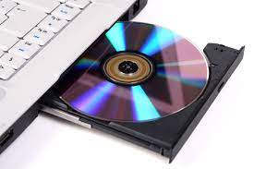

1. **Expansion Cards:**

Certain expansion cards, like sound cards or network interface cards, might require power directly from the PSU if they have auxiliary power connectors. Most of the time, these cards draw power through the motherboard.

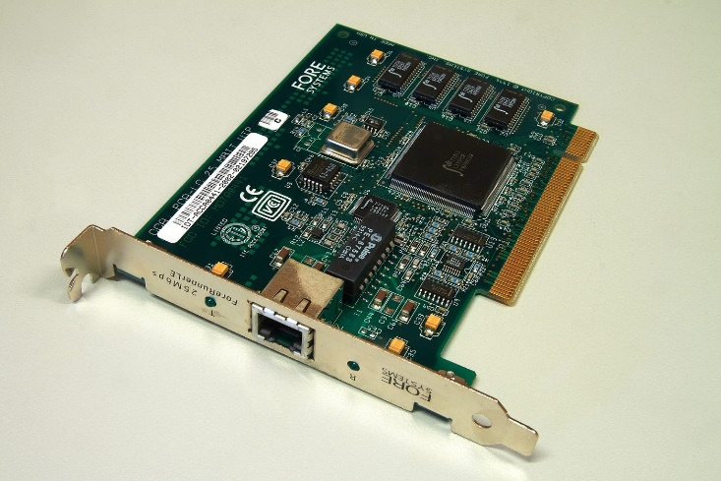

1. **Cooling Fans:**

Fans are used to dissipate heat generated by components like the CPU and GPU. The PSU powers these fans directly if they are part of the PSU or indirectly if they are part of other components (e.g., CPU cooler or GPU cooler).

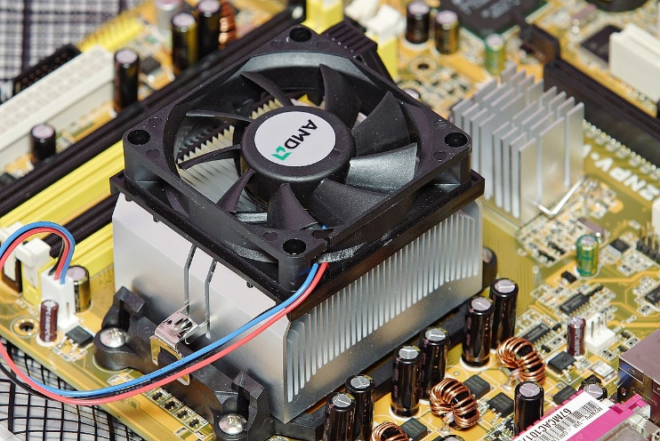

1. **Peripherals:**

Peripherals like keyboards, mice, monitors, and USB devices usually receive power through USB ports or external power adapters, and not directly from the PSU. The PSU's main role here is to power the motherboard, which enables these peripheral connections.

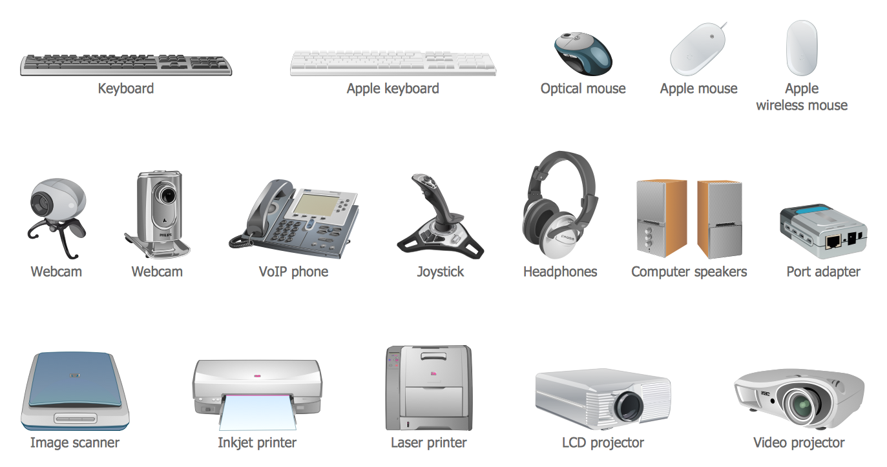

**2.B) Identify the Common Cause of PSU-SMPS Failure & Explain How it can be Maintained in a Health State**

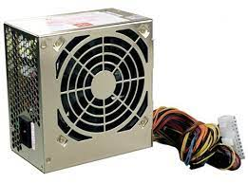

FAILURE

Power Supply Units (PSUs), also known as SMPS (Switched-Mode Power Supplies), are critical components in a computer system. PSU failures can disrupt the entire system's functionality. Common causes of PSU failure and ways to maintain them in a healthy state in computer hardware maintenance and administration are as follows:

* **COMMON CAUSES OF PSU-SMPS FAILURE:**

1. **Overheating:**

Overheating is a common cause of PSU failure. If the PSU's internal temperature rises too high, it can lead to component damage and eventual failure. This can happen due to poor ventilation, a clogged fan, or overloading the PSU.

1. **Dust and Debris:**

Accumulation of dust and debris can clog the PSU's fan and ventilation, leading to overheating. Dust can also cause electrical short-circuits within the PSU.

1. **Electrical Surges:**

Power surges, spikes, and voltage fluctuations can damage the PSU. This can result from electrical storms, faulty power outlets, or sudden power interruptions.

1. **Aging Components:**

Over time, electronic components within the PSU degrade. Capacitors, in particular, can weaken and eventually fail, causing voltage irregularities.

1. **Overloading:**

If a PSU is consistently operated at or near its maximum wattage capacity, it can overheat, degrade, and fail prematurely.

* **WAYS TO MAINTAIN A PSU IN A HEALTHY STATE:**

**1. Proper Ventilation:**

Ensure that the computer case has adequate ventilation and airflow. The PSU should have enough room to dissipate heat effectively. Avoid obstructing the PSU's exhaust fan.

**2. Clean Regularly:**

Clean the interior of the computer case regularly to prevent dust and debris accumulation. Focus on keeping the PSU's fan and intake/exhaust areas clean. Use compressed air to blow out dust.

**3. Use Surge Protectors:**

To protect the PSU from voltage fluctuations and electrical surges, use a quality surge protector or uninterruptible power supply (UPS). These devices can help filter and stabilize the incoming power.

**4. Avoid Overloading:**

Make sure the PSU you choose has a wattage rating that exceeds the total power consumption of all components in your computer. Avoid overloading the PSU, as it can lead to overheating and reduced lifespan. Use online PSU calculators to determine your power requirements accurately.

1. **Replace Aging PSUs:**

As PSUs age, they become more prone to failure. It's a good practice to replace the PSU every 5-7 years or sooner if you notice signs of degradation.

1. **Monitor Temperatures:**

Use monitoring software to keep an eye on the PSU's temperature and other hardware components. High temperatures can be an early warning sign of PSU issues.

1. **Quality PSU:**

Invest in a high-quality PSU from reputable manufacturers. Quality PSUs tend to have better components and longer lifespans.

1. **Check for Strange Noises and Smells:**

Unusual noises like clicking or grinding and strange smells coming from the PSU could be signs of impending failure. Address these issues promptly.

1. **Regular Maintenance:**

Incorporate regular computer maintenance into your routine, which includes checking and cleaning the PSU and all other components.

1. **Professional Inspection:**

If you suspect PSU issues or other hardware problems, consider consulting a professional technician for diagnosis and repair.

**WEEK-4**

**4. A) Compare and Contrast The Different Characteristics of Different Motherboard Components**

Motherboard form factors refer to the physical size and layout of motherboards. Different form factors are designed to fit specific computer cases and have varying features and characteristics. Here's a comparison of some common motherboard form factors:

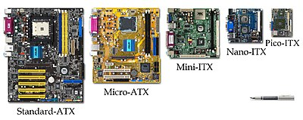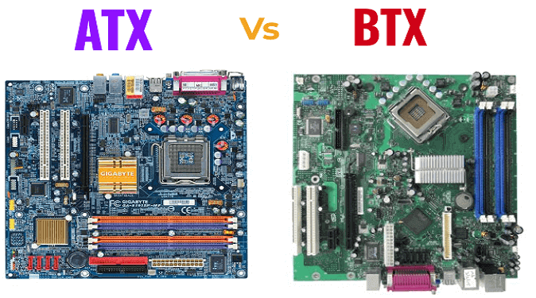 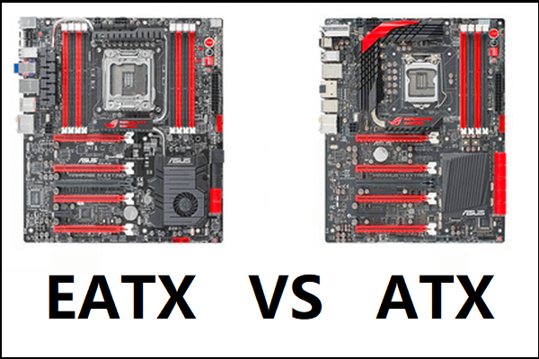

**1. ATX (Advanced Technology Extended):**

* Size: 12 x 9.6 inches (30.5 x 24.4 cm)
* Expansion Slots:Typically 7 or more
* Features: Standard size, plenty of room for components and expansion, multiple RAM slots, multiple graphics card support.
* Use Cases: Standard desktops and workstations.

**2. Micro-ATX (mATX):**

* Size: 9.6 x 9.6 inches (24.4 x 24.4 cm)
* Expansion Slots Fewer than ATX (usually 4)
* Features: Smaller size for compact cases, suitable for smaller builds with fewer components.
* Use Cases: Smaller desktops and budget gaming PCs.

**3. Mini-ITX:**

* Size: 6.7 x 6.7 inches (17 x 17 cm)
* Expansion Slots: Typically just one PCIe slot.
* Features: Extremely compact, limited space for components, often used in small and portable systems.
* Use Cases: HTPCs, small form factor (SFF) gaming PCs, compact builds.

**4. E-ATX (Extended ATX):**

* Size: Larger than ATX, varies.
* Expansion Slots: More than ATX, accommodating multiple graphics cards and other peripherals.
* Features: Suitable for high-end gaming and content creation, extra space for additional components.
* Use Cases: Enthusiast gaming rigs and workstations.

**5. XL-ATX and HPTX:**

* Size: Even larger than E-ATX.
* Expansion Slots: Extensive expansion options.
* Features: Enormous motherboards designed for multi-GPU setups and server-grade hardware.
* Use Cases: Extremely high-end gaming setups, server motherboards.

**6. BTX (Balanced Technology Extended):**

* Size: A design that differs from ATX, not commonly used in consumer PCs.
* Features: It aimed at improving airflow and reducing heat.
* Use Cases: Rarely used in consumer PCs, mostly used in a limited number of OEM systems.

**4.B) Study the Features and Specification of Processors (Intel, Dual-Core, Quad Core, i3, i5,i7,i9 AMD Processors).**

Processors from Intel and AMD come in various models with different features and specifications. Below, I'll provide an overview of these processors, specifically the Dual-Core, Quad-Core, and Intel Core i3, i5, i7, i9 series processors. Note that specific details may vary based on the generation and model of the processor, and the information provided here is based on knowledge up to September 2021.

* **Intel Processors:**

1. **Dual-Core Processors:**

These processors have two CPU cores. Dual-core processors are typically found in budget or low-power systems and are suitable for basic tasks.

1. **Quad-Core Processors:**

These processors feature four CPU cores, providing better performance than dual-core CPUs. They are suitable for general computing, including multitasking, light gaming, and content creation.

1. **Intel Core i3:**

The Core i3 processors are dual-core or quad-core processors, typically with Hyper-Threading technology, which allows each core to work on two threads simultaneously. They are ideal for everyday computing tasks, such as web browsing, office work, and multimedia playback.

1. **Intel Core i5:**

Core i5 processors are quad-core (some are hexa-core or octa-core) with or without Hyper-Threading. They offer a good balance between performance and power efficiency, suitable for gaming, content creation, and multitasking.

1. **Intel Core i7:**

Core i7 processors are typically quad-core, hexa-core, or octa-core CPUs with Hyper-Threading. They are designed for high-end performance and can handle demanding tasks such as gaming, video editing, and 3D rendering.

1. **Intel Core i9:**

The Core i9 processors are the highest-end consumer processors from Intel, featuring octa-core or dec-core configurations with Hyper-Threading. They offer top-tier performance for gaming and professional-level tasks.

* **AMD Processors:**

1. **Dual-Core Processors:**

AMD offers dual-core processors in their A-series and Athlon series. These are budget processors designed for basic computing.

1. **Quad-Core Processors:**

AMD's quad-core processors are found in their Ryzen and Athlon series. They offer good performance for general computing tasks.

1. **Ryzen 3:**

These processors are quad-core CPUs without simultaneous multi-threading (SMT). They provide solid performance for budget gaming and everyday use.

1. **Ryzen 5:**

Ryzen 5 processors are typically quad-core or hexa-core with SMT. They are well-suited for gaming, content creation, and multitasking.

1. **Ryzen 7:**

Ryzen 7 processors are hexa-core or octa-core CPUs with SMT. They offer excellent performance for gaming and demanding content creation workloads.

1. **Ryzen 9**

The Ryzen 9 series features high-end CPUs with up to 16 cores and 32 threads. These processors are designed for enthusiasts, gamers, and professionals who need the best performance available.

**WEEK-5**

**5. A) Explain the Important of UEFI Configuration Settings for Overclocking Of CPU Frequency.**

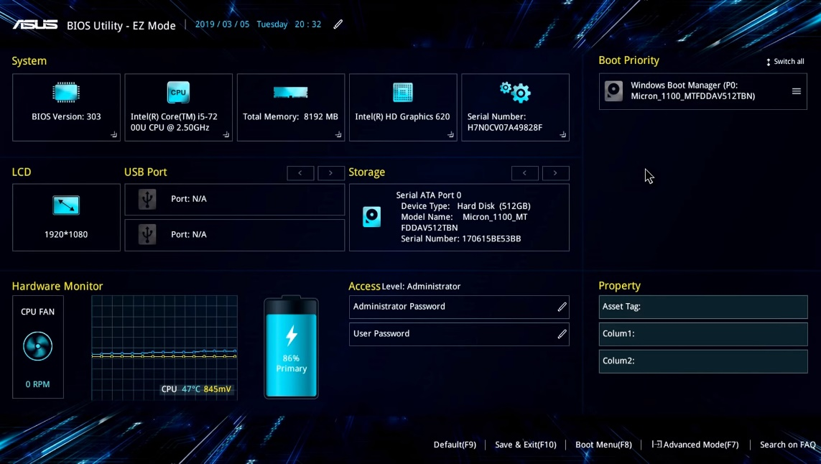

UEFI (Unified Extensible Firmware Interface) configuration settings play a crucial role in the process of overclocking the CPU frequency. Overclocking involves running a computer component at a higher clock rate (more cycles per second) than it was designed for, thereby achieving better performance. Here's why UEFI configuration settings are important for this process:

1. **Voltage Control:**

UEFI allows users to adjust the voltage supplied to the CPU. When overclocking, increasing the voltage can help stabilize the system at higher clock speeds. This feature is essential because higher clock speeds typically require more power, and adjusting the voltage can prevent system instability or crashes.

**2. Clock Multiplier Control:**

UEFI provides the ability to adjust the CPU's clock multiplier, which determines the CPU frequency. Increasing the clock multiplier allows for a higher CPU frequency, resulting in better performance. UEFI enables users to fine-tune this setting to achieve optimal overclocking results.

**3. Memory Frequency Control:**

Overclocking the CPU often involves increasing the memory frequency as well. UEFI allows users to adjust memory timings and frequencies, which can contribute to improved system performance when overclocking.

**4. System Stability Testing:**

Some UEFI configurations come with built-in tools for stress testing and monitoring system stability during overclocking. These tools help users ensure that the system remains stable under increased clock speeds and voltages, reducing the risk of crashes or hardware damage.

**5. Temperature Monitoring and Fan Control:**

UEFI often provides features for monitoring the CPU temperature and adjusting fan speeds accordingly. Overclocking can generate more heat, and having the ability to monitor temperatures and control fan speeds ensures that the system remains within safe operating temperatures, preventing overheating and potential damage to the CPU.

1. **Profile Saving and Loading:**

UEFI allows users to save overclocking configurations as profiles, which can be loaded at any time. This feature is beneficial for users who want to switch between different overclocking settings quickly or revert to default settings if needed.

UEFI configuration settings are essential for overclocking the CPU frequency because they provide control over voltage, clock multipliers, memory frequencies, and system stability testing. Additionally, features such as temperature monitoring, fan control, and profile saving ensure that the system remains stable and safe during the overclocking process.

**5.B) Set RAM Settings, RAM Timings.**

RAM settings and timings can be adjusted in the computer's BIOS (or UEFI) to optimize the performance of the memory modules. These settings can affect the speed and stability of the system. Here's a basic explanation of some key RAM settings and timings:

1. **Frequency (Clock Speed):**

This setting determines the speed at which the RAM operates, measured in MHz. Increasing the frequency can improve the overall performance of the system, but it's important to ensure that the motherboard and RAM modules support the selected frequency.

2. **CAS Latency (CL):**

CAS latency refers to the delay between the time a memory controller requests data from RAM and when it is available. Lower CAS latency values indicate better performance, as the data is accessed more quickly. However, lower CAS latency values often come with a higher price tag.

3. **RAS (Row Address Strobe) to CAS (Column Address Strobe) Delay (tRCD):**

This timing setting represents the delay between activating the row of memory and reading the column of memory. It works in conjunction with CAS latency to determine the overall access time.

4. **RAS Precharge (tRP):**

This timing setting is the delay required to deactivate the current row and begin accessing another row. Similar to tRCD, it affects the overall speed of data access.

5. **RAS Active Time (tRAS):**

This timing setting is the minimum number of clock cycles required to access a certain row of data in RAM. A lower tRAS value can result in faster memory access.

1. **Command Rate (CR):**

The command rate determines the delay between when the memory controller issues a command and when it's executed. A lower command rate can improve performance, but it may not be supported by all systems.

When adjusting these settings, it's crucial to be cautious and make incremental changes, as improper settings can lead to system instability or even damage to the RAM modules. Many modern motherboards provide options for automatic optimization or XMP (Extreme Memory Profile) settings, which can automatically configure the RAM settings to the manufacturer's recommended specifications for optimal performance. If you are not familiar with these settings, it's best to rely on these predefined profiles or consult the motherboard's manual for guidance.

**WEEK-8**

**8.A) Identify the System Required for Windows 10 Instalation.**





**System requirements for installing Windows 10:**

It's important to note that these are the minimum requirements, and for an optimal experience, especially when running more demanding applications or performing tasks that require higher performance, it is advisable to have hardware that exceeds these minimum specifications. Also, the requirements may have changed after my last update, so it's recommended to refer to the official Microsoft website or other trusted sources for the most up-to-date information.

As of my last knowledge update in 2022, the minimum system requirements for installing Windows 10 are as follows:

**1. Processor:** 1 gigahertz (GHz) or faster processor or System on a Chip (SoC)

**2. RAM:** 1 gigabyte (GB) for the 32-bit version or 2 GB for the 64-bit version

**3. Hard disk space:** 32 GB for the 64-bit version or 32 GB for the 32-bit version

**4. Graphics card:** DirectX 9 or later with WDDM 1.0 driver

**5. Display:** 800x600 resolution

**8 . B) Study and List the Features of Different Versions of Windows 10.**

As of my knowledge cutoff date in September 2021, Windows 10 received several major updates, each introducing new features and improvements. Here are some of the notable features introduced in different versions of Windows 10 up to that point:

**1. Windows 10 Version 1507 (Initial Release):**

* + Start Menu: The return of the Start Menu was one of the most significant changes from Windows 8. It combined the classic Start Menu with Live Tiles from Windows 8.
  + Cortana: The introduction of Microsoft's virtual assistant, Cortana, for voice-activated searches and system control.

**2. Windows 10 Version 1511 (November Update):**

* + Microsoft Edge: The introduction of the Edge web browser to replace Internet Explorer.
  + Improved Start Menu: Enhanced Start Menu with more customization options.

**3. Windows 10 Version 1607 (Anniversary Update):**

* + Windows Ink: Added features for digital pen and touch screen users, including a dedicated workspace for inking.
  + Enhanced Security: Enhanced Windows Defender and improved security features.
  + Dark Mode: Introduced a system-wide dark mode for apps and system interface.
  + Windows Subsystem for Linux (WSL): Brought native support for running Linux commands and tools on Windows.

**4. Windows 10 Version 1703 (Creators Update):**

* + 3D Paint: Included Paint 3D, a revamped version of the classic Paint app with 3D modeling capabilities.
  + Game Mode: Enhanced gaming performance with optimizations and a dedicated gaming settings panel.
  + Dynamic Lock: Introduced the Dynamic Lock feature that locks your PC when your Bluetooth-paired phone is out of range.

**5. Windows 10 Version 1709 (Fall Creators Update):**

* + Fluent Design System: Introduced elements of the Fluent Design System to enhance the visual appeal of the Windows interface.
  + Mixed Reality: Added support for Windows Mixed Reality headsets and mixed reality experiences.
  + OneDrive Files On-Demand: A feature allowing access to files stored on OneDrive without taking up local storage space.

**6. Windows 10 Version 1803 (April 2018 Update):**

* + Timeline: Introduced the Timeline feature to view and resume past activities across devices.
  + Focus Assist: Replaced Quiet Hours and helped users manage notifications and distractions.

**7. Windows 10 Version 1809 (October 2018 Update):**

* + Dark File Explorer: Dark mode extended to the File Explorer.
  + Clipboard History: Added a clipboard history feature, allowing users to access previously copied items.
  + Your Phone App: Introduced the "Your Phone" app for better integration between Windows 10 and Android smartphones.

**8. Windows 10 Version 1903 (May 2019 Update):**

* + Windows Sandbox: Introduced a lightweight virtualized environment for testing applications.
  + Light Theme: Introduced a new system-wide light theme for a fresh look.

**9. Windows 10 Version 1909 (November 2019 Update):**

* + Performance Improvements: Focused on performance and quality improvements rather than introducing major new features.
  + Windows Search Enhancements: Improved Windows Search functionality.

**10. Windows 10 Version 2004 (May 2020 Update):**

* + Cortana Redesign: Redesigned Cortana as a separate app with a chat-based interface.
  + Windows Subsystem for Linux 2 (WSL 2): An updated version with improved performance and compatibility.
* **Versions of WINDOWS 10:**

1. Windows 10 Professional
2. Windows 10 Home
3. Windows 10 Home Single Language
4. Windows 10 Education
5. Windows 10 LTSC
6. Windows 10 IoT Core.
7. Windows 10 Server Mode.
8. Windows 10 Enterprise
9. Windows 10 Enterprise LTSB
10. Windows 10 Mobile.
11. Windows 10 Mobile Enterprise.

**WEEK-11**

**Relate the Components of Laptop and Desktop and Compare this features.**

Laptops and desktops are two common types of personal computers, and while they share many similar components, there are differences in their form factors and how these components are integrated. Here's a comparison of the components in laptops and desktops:

**1. Central Processing Unit (CPU):**

* + Both laptops and desktops use CPUs, which are the brains of the computer. They perform calculations and execute instructions.
  + Laptops typically use mobile or low-power CPUs designed for thermal efficiency, while desktops can use higher-performance CPUs, often with more cores.

**2. Motherboard:**

* + Both laptops and desktops have motherboards that serve as the central circuitry connecting various components.
  + Laptop motherboards are smaller and more integrated due to space constraints, while desktop motherboards can be larger and offer more expansion options.

**3. Memory (RAM):**

* + Laptops and desktops both use RAM to store and access data for active processes.
  + Laptop RAM modules are smaller and use SODIMM form factors, while desktop RAM modules are larger and use DIMM form factors.

**4. Storage:**

* + Both laptops and desktops use various storage options, including HDDs (Hard Disk Drives) and SSDs (Solid-State Drives).
  + Laptops often use smaller, mSATA or M.2 SSDs for space efficiency, while desktops can accommodate larger 3.5-inch HDDs and standard 2.5-inch SSDs.

**5. Graphics Processing Unit (GPU):**

* + Both laptops and desktops can have integrated or dedicated GPUs.
  + Desktops offer more flexibility in using discrete graphics cards, providing higher performance for gaming and professional applications.

**6. Display:**

* + Laptops have built-in displays, which can vary in size and quality.
  + Desktops require an external monitor, and the display quality and size can be customized to personal preferences.

**7. Keyboard and Mouse (Input Devices):**

* + Laptops have built-in keyboards and often trackpads for input.
  + Desktops use external keyboards and mice, offering a wider range of choices for ergonomic and gaming preferences.

**8. Battery (Power Supply):**

* + Laptops include built-in rechargeable batteries for portability.
  + Desktops require external power sources and do not have batteries.

**9. Portability and Form Factor:**

* + Laptops are designed for portability, with a compact form factor, integrated keyboard, and display.
  + Desktops are bulkier and designed for stationary use, often requiring additional peripherals.

**10. Expandability and Customization:**

* + Desktops are more customizable and upgradable, allowing users to add or swap components like graphics cards, storage, and RAM easily.
  + Laptops have limited upgradability due to their compact design, with some models allowing for RAM and storage upgrades.

**11. Cooling System:**

* + Laptops have smaller cooling solutions to manage heat in a confined space.
  + Desktops can accommodate larger and more effective cooling solutions, allowing for better thermal management.

**12. Audio:**

* + Laptops typically have integrated speakers and audio output jacks.
  + Desktops often require external speakers or headphones for audio output, but they offer more space for larger, high-quality sound systems.

**WEEK-12**

**Document the Common Fault on the Motherboard**

Motherboard faults can be quite varied, and they can lead to a range of issues with your computer. Here are some common motherboard faults in more detail:

**1. Power Issues:**

* + - No Power: One of the most common motherboard issues is when the computer doesn't power on at all. This can be caused by a faulty power supply, a damaged power button, or a defective motherboard.
    - Intermittent Power: Sometimes, the motherboard might have intermittent power issues, causing the computer to power on sporadically. This can be due to loose connections, damaged capacitors, or overheating.

**2. Boot Problems:**

* + - Boot Failure: When your computer powers on but doesn't complete the boot process, it could be a motherboard fault. Faulty BIOS settings, incompatible components, or damaged motherboard components can cause this.
    - POST Error Codes: If you encounter POST (Power-On Self-Test) error codes during boot, it could indicate issues with the motherboard, CPU, RAM, or other components.

**3. Connectivity Issues:**

* + - USB/Port Failuree: Damaged or malfunctioning USB ports, audio jacks, or other connectors on the motherboard can result in connectivity problems.
    - LAN or Wi-Fi Issues: Network-related issues can be caused by motherboard problems, especially if the onboard LAN or Wi-Fi components are faulty.

**4. Display Problems**

* + - No Display: A motherboard issue can result in a black screen or no display output. This could be related to problems with the integrated graphics (if applicable), the GPU slot, or other display-related components.
    - Artifacting and Graphics Glitches: If you see visual artifacts or glitches on the screen, it might be due to issues with the motherboard's graphics interface.

**5. Audio Problems:**

* + - No Sound: Audio problems can be linked to damaged audio components on the motherboard or driver issues.
    - Interference or Static: If you experience interference, static, or distorted audio, it may be a motherboard fault.

**6. Expansion Slot Issues:**

* + - GPU Slot Failures: A faulty PCIe slot can lead to problems with graphics cards. If you have multiple slots, try moving the GPU to see if the issue is slot-specific.
  + -RAM Slot Problems: Issues with RAM slots can result in memory-related errors, system crashes, and instability.

**7. Overheating and Capacitor Problems:**

* + - Overheating: Overheating can damage motherboard components over time, leading to instability and failure. Ensure proper cooling and ventilation.
    - Capacitor Leaks/Swelling: Damaged or leaking capacitors can result in a range of issues, from instability to power problems. Inspect the motherboard for any visibly damaged capacitors.

**8. BIOS/UEFI Corruption:**

* + - A corrupted or outdated BIOS/UEFI firmware can lead to boot problems, so keeping the firmware up-to-date and properly configured is essential.

**9. Short Circuits and Physical Damage**

* + - Physical damage to the motherboard, such as bent pins, cracks, or burn marks, can result in a wide range of problems. Be careful when handling and installing components on the motherboard.

**WEEK-13**

**Study the Global E-Waste Key Statistics**

Proper e-waste management is a critical consideration in computer hardware maintenance and administration. Responsible disposal and recycling of electronic devices not only help mitigate environmental and health risks but also ensure the sustainable use of resources. It's essential for IT professionals to be aware of e-waste management practices and regulations in their regions to contribute to responsible e-waste disposal and recycling.

Certainly, here are key global e-waste statistics related to computer hardware maintenance and administration:

**1. E-Waste Generation:**

* Globally, approximately 53.6 million metric tons of electronic waste (e-waste) was generated in 2019. This includes discarded computers, laptops, smartphones, and other electronic devices.

**2. Per Capita E-Waste Generation:**

* + The per capita generation of e-waste varies significantly by country. In 2019, Norway had one of the highest per capita e-waste generation rates at 26.0 kilograms per person, while many African nations had much lower rates.

**3. Recycling Rates:**

* + Worldwide, only around 17.4% of e-waste generated in 2019 was formally collected and recycled through proper channels. The majority of e-waste ends up in landfills or is managed improperly, posing environmental and health hazards.

**4. Informal E-Waste Recycling**

* + A substantial portion of e-waste is managed through informal recycling and disposal practices, often in developing countries. These methods can involve dangerous practices like open burning and the use of toxic chemicals, resulting in significant environmental and health consequences.

**5. E-Waste Composition:**

* + E-waste includes a wide range of electronic and electrical equipment, such as old computers, laptops, smartphones, tablets, televisions, household appliances, and electronic toys.

**6. E-Waste Growth:**

* + The volume of e-waste generated is expected to continue growing due to increasing consumer electronics consumption, as well as shorter product lifecycles and constant technology upgrades.

**7. E-Waste Environmental Impact:**

* + E-waste contains hazardous materials, including heavy metals (lead, mercury, cadmium) and toxic chemicals (such as brominated flame retardants). Improper disposal can lead to soil and water contamination, air pollution, and health problems for those exposed.

**8.Economic Value of Recovered Materials:**

* + E-waste contains valuable materials like gold, silver, copper, and rare earth metals. Proper recycling and recovery processes can not only reduce the environmental impact but also provide economic opportunities through the extraction of these materials.

**9. Global E-Waste Management Initiatives**

* + Various countries and international organizations have implemented initiatives to improve e-waste management and recycling. These initiatives aim to promote environmentally friendly practices, raise awareness, and reduce the negative impacts of e-waste on both the environment and human health.